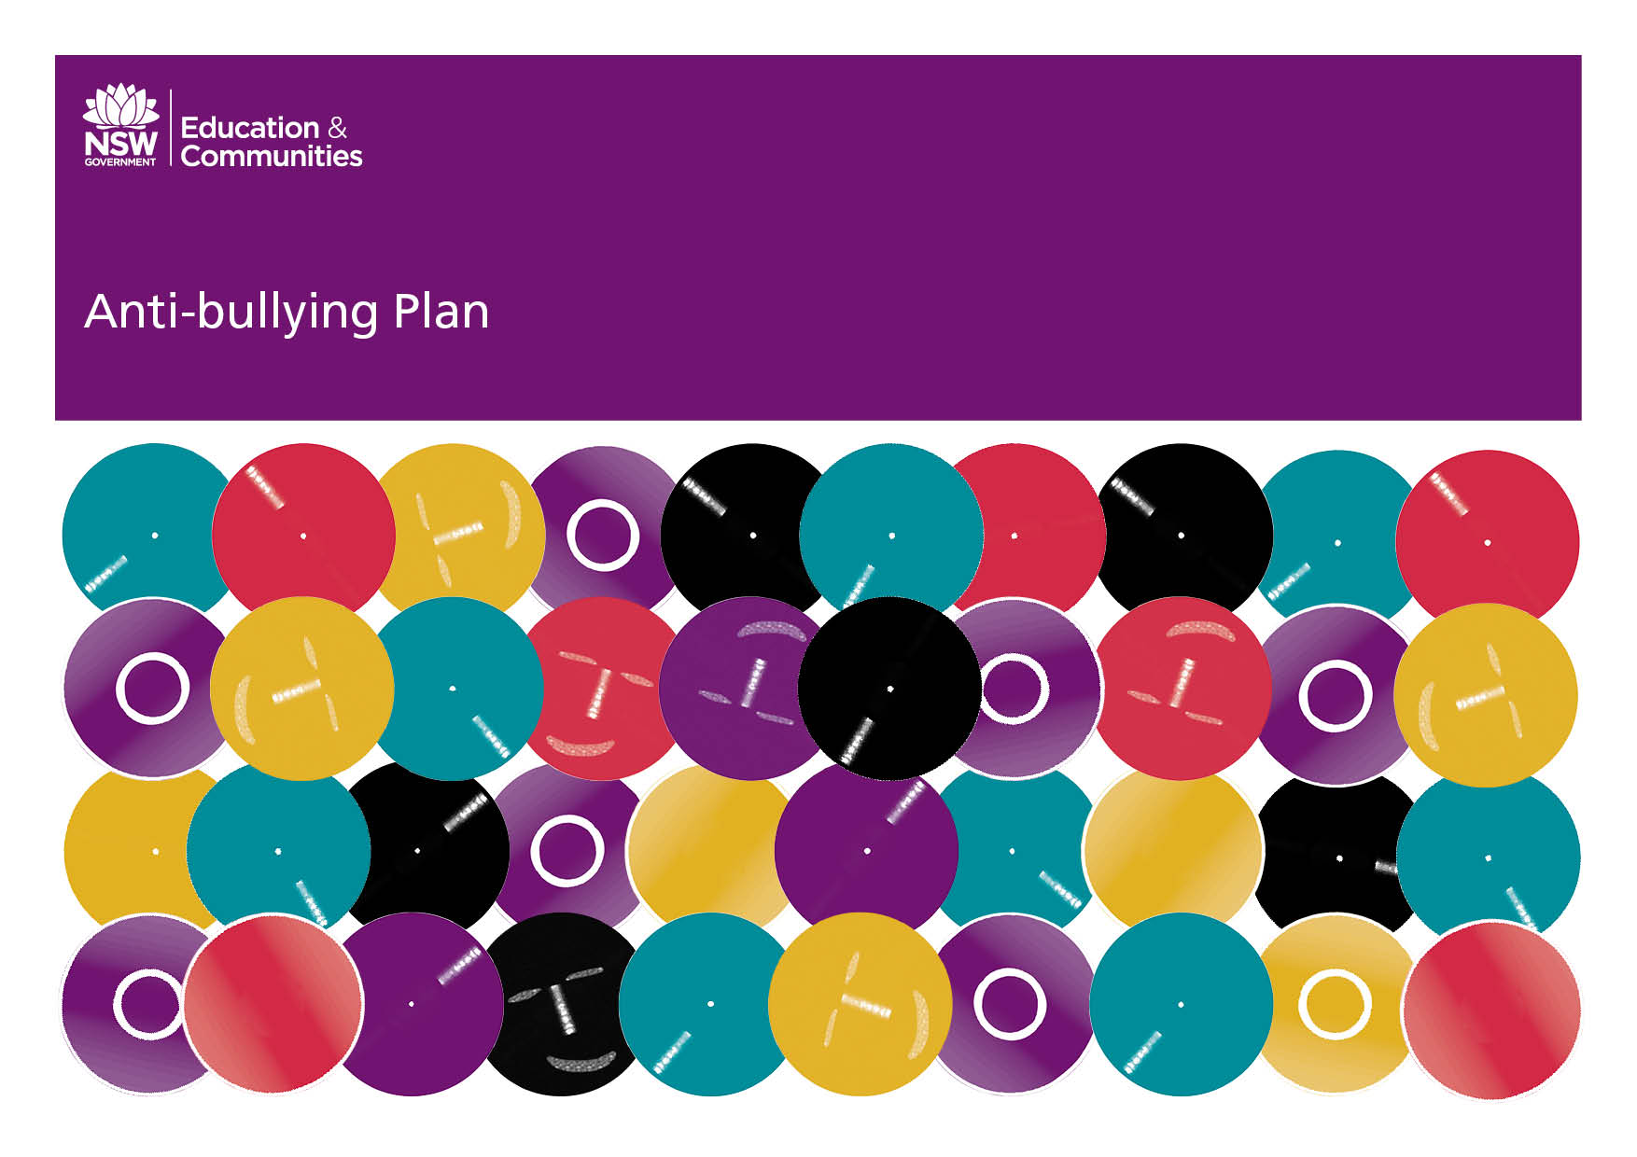
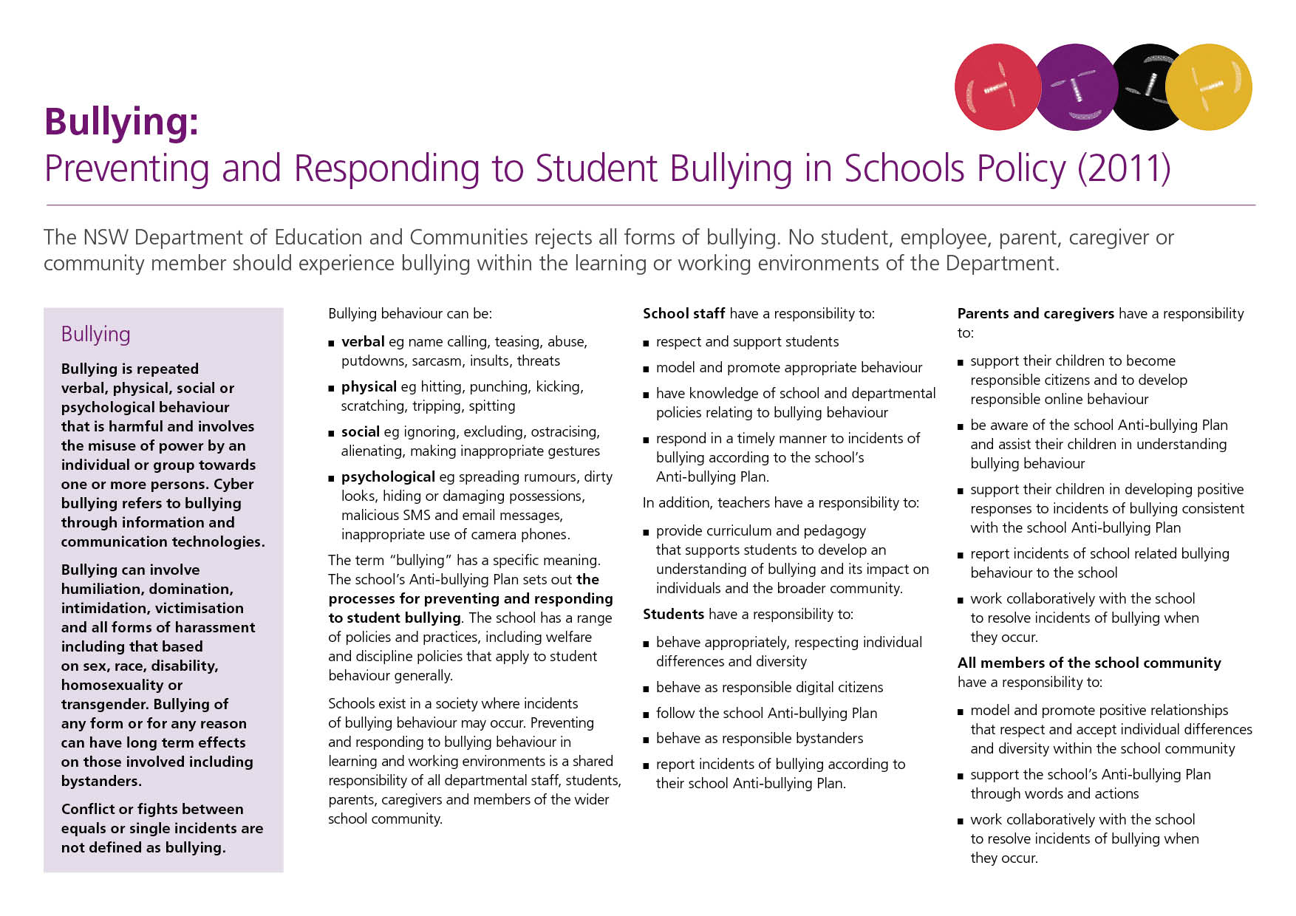
Our School Anti-Bullying Plan
Baradine Central School 2014 Reviewed December 2015

Our School Anti-Bullying Plan
This plan outlines the processes for preventing and responding to student bullying in our school and reflects the Bullying: Preventing and Responding to Student Bullying in Schools Policy of the New South Wales Department of Education and Communities.
The Baradine Central School Anti-Bullying Plan has been developed collaboratively with students, school staff, parents, caregivers and the community. Stakeholder meetings and surveys were conducted to facilitate planning discussions. Data was collected from:
- School Life survey responses from students Y2-Y12 2013 + 2014.
- Bullying Survey -100% of students and staff completed a Bullying Survey and 46% of parents/caregivers.
Staff researched and accessed available resources from the internet and developed a comprehensive resource bank to support the teaching of preventive programs K-12 to address Anti-bullying. A scope and sequence of teaching units was updated and implemented in the school’s curriculum.
Collaboration with parents occurred throughout 2014 at P&C meetings. The draft plan was presented to P&C at a meeting on November 11. Parents were invited to view the draft plan posted on the school’s website or pick up a hard copy from the office. Feedback was invited from the school community on the draft plan for a two week period ending on December 1. The plan was implemented in Term 1 2015 and will be evaluated on an ongoing basis. It will be formally reviewed once every year.

Statement of purpose
Baradine Central School (BCS) believes it is every student’s right to attend school and to learn in a safe and supportive environment. At BCS we will:
- Create a culture where it is acceptable and encouraged to report incidents of bullying; and
- Empower students by listening to their experiences and allowing them to feel that they can be in control of what happens to them at school.
Outcomes
As a result of implementing an Anti-bullying Plan, we establish baseline data and strive to see:
- Baradine Central School providing a safe place for students K-12 to learn and play;
- an increase in the number of students K-12 who report bullying behaviour;
- the incidence of bullying behaviours being reduced;
- improved attendance data for identified victims;
- improved performance in school work;
- Baradine Central School staff utilising the plan and procedures as set out in the Anti-bullying plan;
- Baradine Central School students using strategies and procedures as set out in the plan and taught by staff in the classroom; and
- Parents recognising and supporting the school’s Anti-bullying plan.
- PBL links to “safety”

Protection
What is Bullying?
Bullying is defined as repeatedly hurting another person may be less powerful- either physically or psychologically. Bullying can take many forms. We consider the following behaviour to be bullying:
1. Physical
including hitting, punching, shoving, pinching, tripping, spitting, scratching, damaging, hiding or stealing belongings or throwing objects at someone.
2. Verbal
name-calling, making offensive remarks, taunting, teasing, put-downs
3. Indirect Social/Psychological
spreading rumours, gossiping about or embarrassing someone, making fun of someone, using threatening looks or gestures, excluding or threatening to exclude from groups, ignoring, ostracising or alienating.
4. Cyber (Online Bullying)
verbal and indirect social/psychological bullying through use of technology such as emails, blogs, websites, social media etc.

Characteristics of Bullying
Bullying behaviour typically contains seven elements:
- An initial desire to hurt.
- Bullying desire is acted out- some form of bullying is perpetrated.
- This action is hurtful.
- There is an imbalance of power- the bullying behaviour is stronger and more powerful than the victim’s behaviour, either physically or psychologically.
- There is no justification for the action- i.e. the victim has done nothing to deserve such treatment.
- It is persistent and repeated.
- The person bullying derives enjoyment from hurting the victim.

Strategies We Will Use to Deal with Bullying
At Baradine Central School we will:
- Review actual bullying incidents
- Collate data on the number of bullying incidences reported by students, parents and also through the negative referrals system.
- Staff will model appropriate communication strategies.
- Reinforce respectful attitudes and communication through the PBL fortnightly focus.
- Openly talk about bullying- what it is, how it affects us and what we can do about it.
- Teach our students the skills which build their self-esteem, resilience and empower them to take the responsibility for themselves- and give them the opportunity to practise these skills.
- Respond to substantiated instances of bullying behaviour in accordance with the school's discipline and welfare policy and all relevant NSW Department of Education and Communities (DEC) policies and procedures.

Responsibilities of Staff
All staff have a responsibility to:
- model appropriate behaviours at all times;
- respect and support each other;
- be aware of Anti-bullying Plan and know where to locate a copy; digital curriculum and hard-copy at Front Office.
- teach students skills and strategies to deal with bullying as per the lessons distributed to staff.
- deal with all reported and observed incidences of bullying as set out in this plan and the school's discipline policy;
- ensure that students are supervised at all times;
- report incidences of bullying to the Head Teacher, Assistant Principal or Principal consistent with school welfare reporting procedures.
- create a culture where it is acceptable and encouraged to report incidents.

Responsibilities of Students
All students have a responsibility to:
- be assertive - Tell the "bully" that they don’t like the behaviour, how it makes them feel and that how they must tell a teacher about it if the person continues;
- see a teacher or ask to see the Principal if the perpetrator/s do continue;
- "Tell” if they are being bullied or if they see someone else being bullied - both at school or on the way to and from school;
- report any cyber-bullying to their teacher or Principal (do not delete any emails or make note of any websites);
- ask to see the Principal directly to report incidences of bullying if the teacher is busy with other playground issues, or if they would prefer to do so;
- help someone who is being bullied; and
- not bully others.

Responsibilities of Parents/Caregivers
All parents/caregivers have a responsibility to:
- watch for signs their child may be being bullied;
- speak with someone on the staff at Baradine Central School if they suspect their child is being bullied; and
- instruct their children to “tell” if they are bullied.
Prevention
A K-12 prevention program featuring detailed scope and sequence aligned with the school’s Positive Behaviour for Learning (PBL) program to be implemented with fidelity. Students are supported both in victim and in bully roles.
Staff use the scope and sequence resource to educate students on ways they can protect themselves and others from bullying behaviours. Lessons are explicitly taught and adapted, particularly within the Stage 5 PDH Curriculum, so that all students can be involved in learning key concepts.
Not only do lessons provide students with effective strategies to deal with bullying behaviour, those who may possibly witness bullying behaviour, "bystanders", are educated on what they can do to help possible victims of bullying behaviour.
In relation to cyber-bullying, students and the community are also educated through information sessions the principal organises with police and motivational speakers, newsletter snippets and articles that they can:
- Guard their contact information i.e. only give your mobile phone number, instant messaging name or e-mail address to trusted friends, and keep a note of who you’ve given it to. Consider using caller ID blocking to hide your phone number when making calls. Similarly, don’t leave your name on your voicemail. Don't give your details to people you don't know – or don’t want to know!
- Take a stand against cyber-bullying i.e. Speak out whenever you see someone being mean to another person online. Most people respond better to criticism from their peers than to disapproval from adults.
When needed, the Principal will hold an anti-bullying information session for parents outlining not only the school's Anti-Bullying Plan, but strategies they can employ to help prevent their child from becoming a possible victim of bullying.
This Anti-Bullying Plan will be made available for viewing and reference on the BCS website.

Early Intervention
Students identified through the LST/PBL referral system with needs relating to bullying are targeted for intervention. The intervention strategies are designed to meet the causes of the bullying behaviours and include:
- build and improve social skills/resilience
- ongoing PBL Tier 2 social skills programs and other strategies such as Check in Check Out, Check and Connect.
- Resilience training is also built into class Personal Development & Health programs.
- Ensure students know who the anti-bullying officer is.
- Students can also self-refer to the anti-bullying officer.
- Parents can make referrals to anti-bullying officer for their child.
- Students can notify anonymously by using the anti-bullying box which will be located in the front office.
- Students can be provided with a buddy or mentor.
Those students who are at risk of being ongoing victims of bullying type behaviour, will be encouraged to report directly and immediately to a member of staff that they themselves have nominated when they feel either threatened or intimidated. Their parents will also be informed of this arrangement so that they too can reinforce this strategy with their child. These early intervention arrangements for students at risk will be communicated to all teaching staff.
Response
Baradine Central School aims to develop skills in all students recognise and react positively to bullying.
Students in Stages 3, 4, 5 & 6 (Yrs 5-12) will create anti-bullying videos focusing on responsible bystanders
Staff will be trained on how to identify bullying issues and how to correctly complete referral documentation.

Reporting Bullying
Incidences of bullying can be reported immediately to any teacher or the Principal by students and their parents. Any bullying incidences reported will be investigated and recorded by the Head Teacher and the Assistant Principal.
Consequences for the perpetrators of clearly substantiated bullying behaviour will also be imposed as outlined in the school’s discipline policy and if necessary, suspension procedures.

Responding to Reported Incidences of Bullying
When a bullying incident is reported or observed the following procedures will apply:
- Children involved speak with Head Teacher, Assistant Principal, Principal about the incident.
- If clearly substantiated, and depending on the nature of the incident, the student responsible for bullying is issued with a negative referral for the incident and is warned of the consequences for further incidences (i.e. blue slip and detention).
- If it is noted that a student is repeatedly perpetrating bullying behaviours, a behaviour management plan will be developed for him/her in consultation with his/her parents to help modify behaviour and reduce risk to other students.
- In the case of cyber-bullying initiated through school accounts, the student may have their DET account blocked for a period determined by the Principal - subsequent consequences for this behaviour determined in line with the school’s discipline policy.
- Inform other staff of the incident.
- Monitor the behaviour of the students involved.
- If aggression is repeated, student will receive a consequence in accordance with BCS Welfare Policy.
- If the student continues to bully, make an appointment to speak to the parent/carer. Remind them of the policy and ask for their cooperation in stopping the child from bullying other students. Develop a behaviour management plan if necessary.
- If bullying behaviour does not stop, student may be suspended as per the school discipline policy.
- Victims of bullying will have access to school counsellor support if the need exists or the student so requests it.

Reporting Instances of Cyber-bullying
If students are being harassed online, they are encouraged to take the following actions immediately:
- Tell an adult you trust. This can be a teacher, parent, older sibling or grandparent - someone who can help you to do something about it.
- Leave the area or stop the activity. People who bully get their kicks from knowing they’ve upset their target. Don’t let them know they’ve upset you, and you’ve taken away half their “fun”. Easier said than done when it’s face-to-face, but if it’s on your mobile or the Internet - easy!
- Block the sender’s messages. If you are being bullied through e- mail or instant messaging, block the sender’s messages. Never reply to harassing messages.
- Keep a record. Save any harassing messages and record the time and date that you received them.
- Advise your Service Provider. Most service providers have appropriate use policies that restrict users from harassing others. They can respond to reports of cyber-bullying over their networks, or help you track down the appropriate service provider to respond to.
- Report to police. If the bullying includes physical threats, tell the police. Some people think that they can get away with it because they believe it is anonymous. They are wrong. Most can be traced and it’s a criminal offence to use a mobile phone or any form of communication to menace or harass or offend another person.
BCS will develop a flowchart of consistent procedures for reporting bullying incidents including an anonymous method for victims who are scared. Poster displays will also be created to promote and remind students of what a responsible bystander/good citizenship looks like.

Procedures & Timeframes
Baradine Central School will implement the following procedures and timeframes when an incident of bullying is reported to the school.
- Bullying notifications are dealt with promptly
- investigation by executive including student statements
- referral to LST/PBL Team
- parent contact
- detention and /or suspension advice
- anti-bullying support for perpetrator in detention

Matching Interventions with Type of Bullying
Baradine Central School will develop a system to appropriately match planned combinations of interventions to each particular incident of bullying.
The four broad categories for bullying are:
- Physical
- Verbal
- Indirect social/psychological
- Cyber
The PBL team has developed a list of types of bullying behaviour from the data collected from the 2014 Bullying survey. They are:
- extortion (physical)
- gossip (verbal)
- excluded (Indirect social/psychological)
- threats (verbal)
- theft (physical)
- teasing (verbal)
- name calling (verbal)
- physical 1.
The PBL team will train staff and students as required using scenarios developed with matching consequence.

Student Support
Strategies and programs Baradine Central School will implement to support any student who has been affected by, engaged in or witnessed bullying behavior include:
- LST referral to school counsellor
- Lunch time AB program for those who engage in bullying behaviours
- PBL Tier 2 interventions

Communicating Updates to Community
Baradine Central School systematically plans for providing regular updates, within the bounds of privacy legislation, to parents and caregivers about the management of bullying incidents that have been reported to the school.
Parents and caregivers have access to this plan and the DEC policy on the school’s website. In addition, regular updates on incident management are provided in the school’s newsletter.
The Principal or executive will personally contact parents/caregivers of students involved in bullying incidents (perpetrator, victim and bystander).

Procedures for Reporting to Police
Baradine Central School’s procedures for reporting incidents involving assaults, threats, intimidation or harassment include immediate reports to the local police and the DEC’s Safety & Security Unit in Sydney.
These procedures are consistent with DN10/00225 - Reporting incidents involving assaults, threats, intimidation, or harassment and Incident Reporting Policy
Staff are familiarised with these policies at Staff Development Day training.

Procedures for Contacting the Child Wellbeing Unit or Community Services
When necessary, the principal will make a report the Child Wellbeing Unit or Family & Community Services.
Staff and executive are provided annual training in the procedures for making notifications.

Departmental Appeal Procedures
The school’s procedures are consistent with the Department of Education & Communities’ (DEC) policy. If parents and caregivers are dissatisfied with the outcome of a bullying incident they can access the DEC’s Complaints Handling Policy on the DEC website to lodge an appeal.
http://www.dec.nsw.gov.au/about-us/how-we-operate/how-we-handle-complaints
Staff are trained annually at SDD on contents of Complaints Handling Policy.

Strategies to identify patterns of bullying behaviour
The school is committed to the early identification and intervention of any bullying behaviours. The LST and PBL teams meet weekly and analyse all referrals and data on the school’s new system ‘Sentral’. Patterns of bullying behaviours or victim behaviours are identified and responded to quickly.

Promotion of Anti-Bullying Plan
Baradine Central School will promote and publicise this Anti-bullying Plan, biannually, including how it will be made widely available to the school community available on any school website.
The school had a major focus on Bullying in 2014, with the collaborative development of this plan, the teaching and learning units of works, strategies and quality resources. Awareness raising in the school’s community was achieved through information sessions with:
- Workshops and discussions at junior, middle and senior SRC meetings.
- Students acknowledged for publically for positive bystander action.
- Bullying survey completed by students, staff and parents/caregivers. Results communicated at Bullying No Way Day.
- the Police Youth Liaison Officer – address to Secondary students and staff.
- Centacare’s workshops delivered to Primary classes and their parents.
- Simon Clegg, motivational speaker, delivered an address to Secondary students and their parents.
- Whole School Assembly where all classes presented key anti-bullying messages through art, poetry, film etc.
- Public launch on Baradine Central School’s Anti-Bullying Plan during Bullying No Way Day November 13th, 2014.
- Media coverage of the Bullying No Way Day and Simon Clegg’s presentation.
The school will continue to promote anti-bullying and inform the community of its positive actions.

Monitoring and Evaluation of the effectiveness of Anti-bullying Plan
Baradine Central School is committed to monitoring and evaluating the effectiveness on this plan. The school community will be surveyed annually and LST and PBL teams will make annual reports from the referral systems. All appropriate data will be collated and analysed to determine if incidences of bullying are reducing over time.

Reporting on the Effectiveness of the Anti-bullying Plan.
Baradine Central School will report annually to the school community on the effectiveness of the Plan. The principal will provide a formal report in the document Annual School Report. This is published each year in May and parents/caregivers can access it electronically on school’s website or collect a hardcopy from the school’s office.
Positive anti-bullying messages will also be posted on the school’s Facebook page.

Reviewing Anti-bullying Plan
The plan and strategies put in place will be evaluated on an ongoing basis and will be formally reviewed at least once every three years by:
- noting if there has been a reduction in reported or observed incidences of bullying;
- noting if there has been a change in the ethos of our school. ie. a culture within the school which makes it safe to “tell”- without fear of reprisals; and
- speaking to parents who have reported incidences to find out if the problem has been resolved.
Additional Information
Contact Information for the Police
Baradine Central School has an established partnership with Police Youth Liaison Officer and School Liaison Police Officer who visit the school regularly to support with the implementation of this Plan. Set topics will be agreed on for these visits.
YLO TBA
SLO Senior TBA
Contact Information for Appropriate Support Services
Students are provided with contact information for support services such as Kids Helpline, Mission Australia.
A list of available services is communicated through the school’s newsletter, website and Facebook page. Palm cards & magnets are accessible for students at the school.

Other Support
Additional information, resources and support relating to effective anti- bullying strategies can be found at:

Bullying No way! www.bullyingnoway.com.au

Kids Help Line www.kidshelpline.com.au

Reach Out! www.reachout.com.au

Bullying Among Young Children: A guide for parents by the Australian Attorney General’s Department. To get your copy, call 1800 708 777.

Principal’s comment
Baradine Central School strives to provide a quality education for all students targeting their educational and social needs in an environment free from violence, harassment and bullying. In response, this plan has been developed and revised in consultation with staff, students and parents/caregivers of the Baradine Central School community.
We look forward to empowering ourselves and others to better address bullying type behaviours and reduce its otherwise negative impact on victims. Thank you to all who actively contributed to the development of this plan and its ongoing evaluation and review.
Mrs Christine Clarke
31/10/14

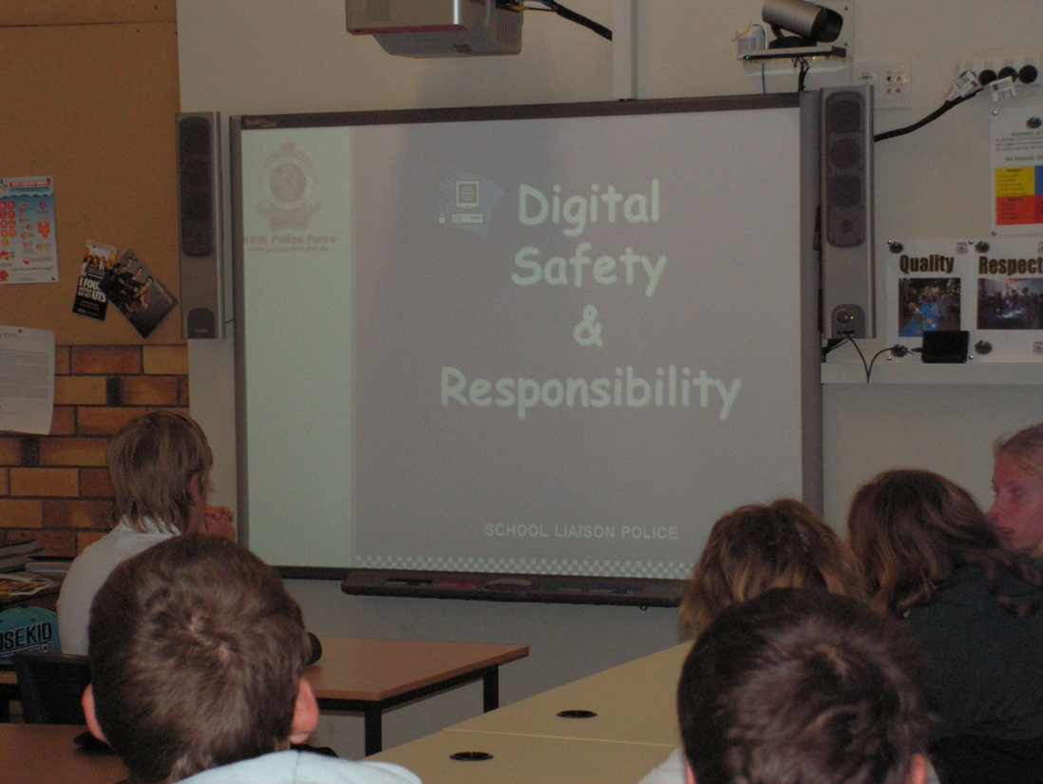
Plan Development Team

Christine Clarke Principal
Lizzie Horder Assistant Principal
Tim Lloyd Head Teacher
Lucy Baldock PBL Team Leader
Sharon Wilson Parent Representative
Karen Reinhardt Parent Representative
Nicole Nielsen Parent Representative
Sophie Horder School Captain
Jacinta Pickette School Captain
Reece Buckton School Vice-Captain
Lahni Patterson Prefect
Mia White Primary School Captain
Clinton Lennon Primary School Captain
Stephanie Bowling SRC Y9
Stacey Tanner SRC Y10
Caleb White SRC Y10
Victoria Gundry SRC Y10
Sandy Vallette SRC Y3
Madison Masman SRC Y5
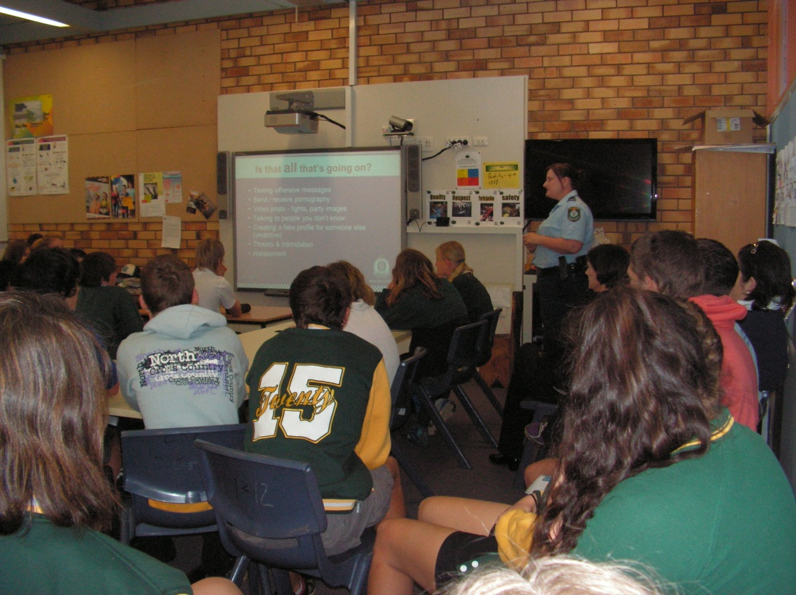
Nigel Lennon SRC Y5

School contact information
Baradine Central School
Narren Street
Baradine
Ph: 0268431805
Fax: 0268431751
Email: baradine-c.school@det.nsw.edu.au
Web: www.baradine-c.schools.nsw.edu.au

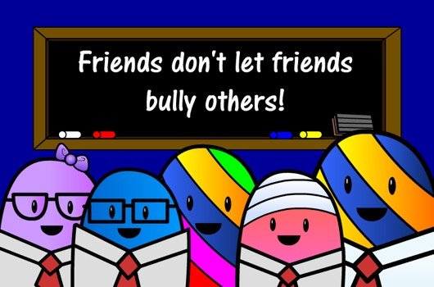
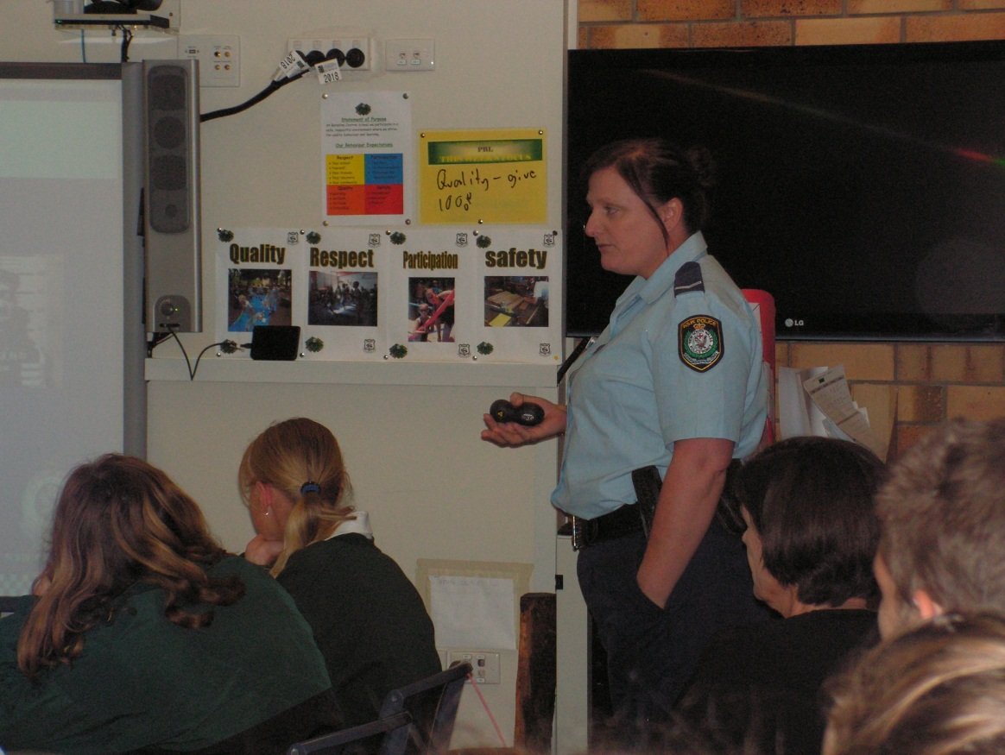

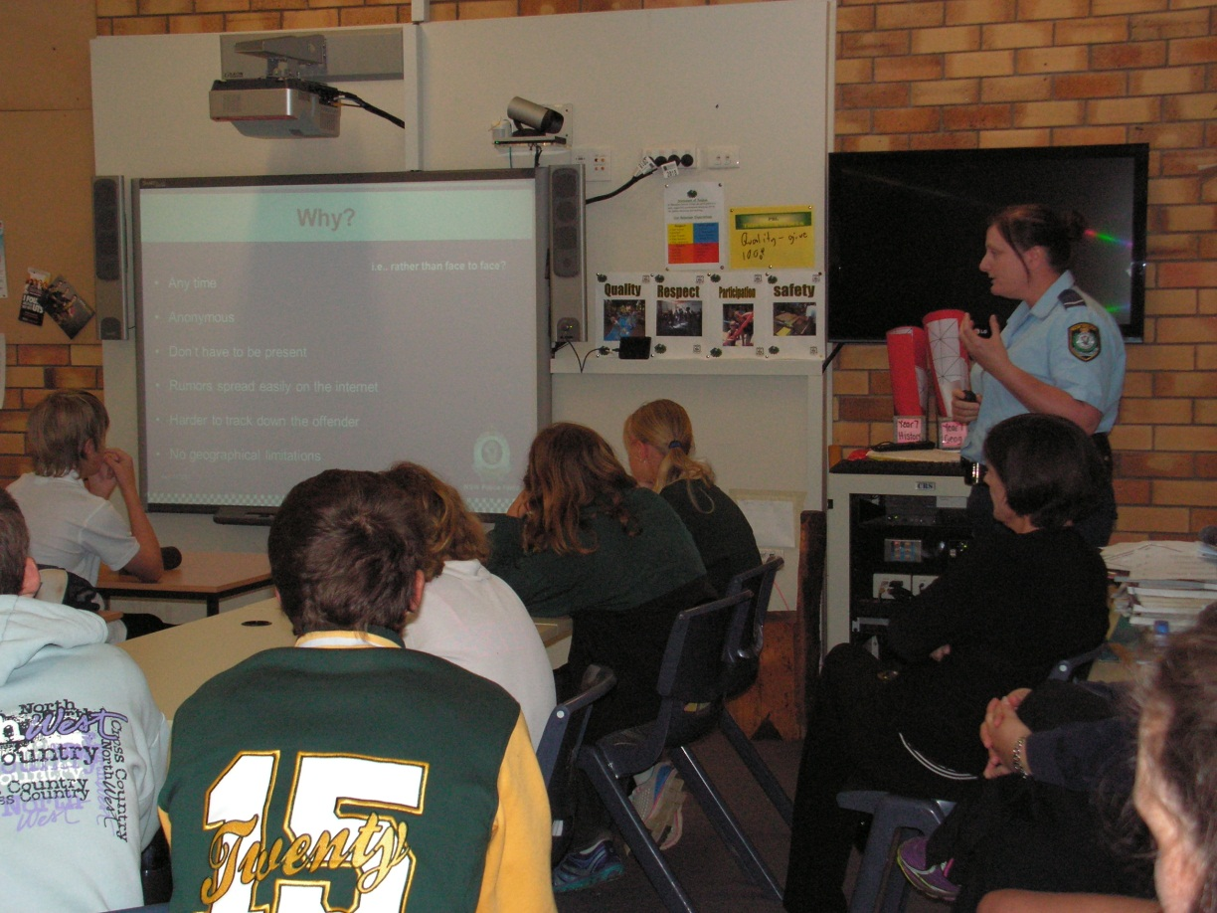

Websites for former victims of bullying | Inspirational guests | Ian Lillico | Survey monkey – all stakeholders (Tim) | System – daily, weekly, term | Copy & record evidence – phone texts, photos, videos, statements | Posters | Media coverage | Must be positive
Bruce Sullivan Mudgee  Lorraine Taylor | Guest Speakers | Social media expert | PBL /RISC | Data collection | Clear record keeping – complaints + conclusions following investigations | Website | Promotion | P&C
Counsellor + DGO | Police YLO | Dylan Crawley – Managing the Bull program  Shine | School life survey | SRC anecdotal information |  | Facebook | Newsletter – snippets of advice | Anti-bullying Day at school
YouTube videos | Resilience training Year 2 - Lee | Lions, Rotary, Apex resources  Helpline numbers displayed | Guest Speakers | Data collection | Promotion | DEC Pam Sharkey  Effective programs  Form a committee  Include SRC | Educate students  Educate staff  Inform parents | Resilience training
Case studies from other public schools | Awareness Raising | Set topics e.g.  How to recognise if you are being bullied | Awareness Raising | Anti-Bullying Planning  T2 2014 | Plan/Policy Development | Cyber Bullying | Plan/Policy Development | Parent meeting  Liaise with police
Assembly address  SRC role  Class PowerPoints | Student mentor/buddy system | Anti-bullying units PDHPE  Self –esteem units | Teaching Resources | Internet Resources | Professional Learning | DEC template  Management plan for eradicating bullying | Launch day (21st March nationally) | Strict enforcement of policies
Library books | Specific programs | Peer mediation training | Bullying. No way. | Stopbullying.gov | Bully Zero website | DEC website :  e-learning modules | PIKAS method  Language for mediation | Counsellor  L&ST
DVDs  posters | Teaching Resources | Friendly Schools Friendly Families | Reach out .com | Internet Resources | DEC website for Anti-bullying | Sharing other schools’ plans | Professional Learning | Revisit PBL monitoring system
Healthy Harold cyber focus | Young Leaders resource | Audit what BCS already has and what is has done | Angels Goal | Better buddies |  | PBL Tier 2 | Complaints handling policy | Mental health team

